Designing, Building, and Testing a Software Feature:
Training Audit Recorder

Victor Israel

November 2, 2026

Designing, Building, and Testing a Software Feature

Feature Selection and Rationale

I chose functional requirement FR-01 and user story US-01: “As a trainer, I want to record a training audit, so that I can preserve a clear, consistent observation” for Assignment 2. These are the most practical first features to implement because later features such as coaching, dashboard, and export functions will depend on the existence of trustworthy audit records. Additionally, a working entry form will allow stakeholders to evaluate the feature as it is developed, rather than after all features have been completed. The intended user for this feature is a trainer who needs to record a process area, date of observation, result, and non-identifying note for a training audit. The success criteria for this feature are that valid entries are assigned a unique ID, are displayed after being saved, and are available after a page refresh. I am keeping this increment of functionality very narrow. It does not assign coaching actions, nor does it display department-wide performance metrics. It supports the incremental Agile approach proposed in Assignment 1 for the functional requirements of the Training Audit and Coaching Tracker. It will allow us to assess the validation, interface clarity, and persistence of the audit-recording functionality.

Software Design and Quality Attributes

A component diagram for the audit recording workflow is given in Figure 1. Browser presentation includes an HTML form, with responsive CSS, and JavaScript for collecting input, for rendering feedback, and for reloading the list of recent records. The HTTP handler receives JSON on POST /api/audits and returns the saved records on GET /api/audits. AuditService delegates field validation to validate_audit() and passes on the valid values to AuditRepository. The repository is implemented with parameterized SQLite statements. The audits table is responsible for the numeric primary key and for the integrity constraints. A successful insert returns an identifier such as AUD-000001 which is readable. The separation of interface and SQL is to allow for later extensions to coaching and reporting.

To make form interactions as predictable as possible, I designed the form to have explicit labels for all required fields, to list the two possible results as radio cards with explanatory text, to include a character counter for the note field, and to include a live status region for confirming successful saves. Instead of highlighting error fields with color, I provide clear error messages for each field that fails validation, as suggested by the World Wide Web Consortium (2023) for error-identification and labeling. The page is designed to be responsive, scaling down nicely for smaller screens. I rely on both server-side validation and database-level constraints for reliability, because, as the OWASP Foundation (n.d.) points out, browser-side checks can be bypassed. For the date, I require it to be a valid date and to be in the past. For the process area and the result, I require them to be from fixed lists. For the observation note, I require it to contain between 10 and 500 characters. For maintainability, I design the service and the repository to be focused on their respective responsibilities, use named functions, and write reproducible tests. This is an educational prototype, not a secure system for production use. Thus, it lacks identity verification, and it cannot automatically determine whether a note contains personal information. I make these deficiencies explicit, rather than hiding them under a polished interface.

Figure 1

Component Diagram for FR-01 Audit Recording
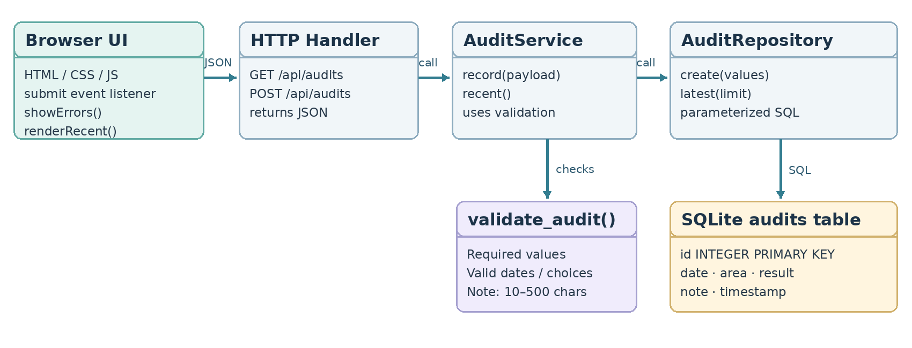
The horizontal arrows are requests or service calls; the vertical arrows are for validation and database operations. The model is consistent with the included source files.

Implementation and Reflection

I chose the smallest possible user story for Assignment 2: functional requirement FR-01, Training Audit Recorder, and user story US-01: “As a trainer, I want to record a training audit, so that I can preserve a clear, consistent observation.” I chose to implement this feature as a small local web application, using standard-library components for Python’s HTTP server and SQLite, and standard-library HTML, CSS, and JavaScript for the browser presentation. This choice avoided the need to install any extra packages, and made the code easier for the grader to run. The browser presentation submits an audit as JSON, which is validated by the service and committed to the database by the repository, returning the assigned ID. The recent-records panel is able to read the saved audits from SQLite and display them, confirming that the save was not temporary. The included source files and the README document the execution of the application; Figure 2 shows an actual successful API response.

The model in the diagram is very similar to the source code files for the implemented feature. The main differences are that the model does not show the coordination of error messages between the service and the browser, the protection of stored notes from being interpreted as HTML, and the closing of database connections after each request. There was also a form-reset event in the browser code that was hiding the success message after saving, which I have now fixed. For future user stories, I would write the API request/response examples before writing the interface, and then write browser-based end-to-end tests earlier in the process. This would help to reduce the amount of integration work required as more user stories are added.

Figure 2

Implementation Evidence: Successful HTTP Record Creation

POST /api/audits → HTTP 201 Created
"message": "Audit saved."
"id": "AUD-000001"
"observation_date": "2026-11-02"
"process_area": "Rebin"
"result": "Meets Standard"

Note. Excerpt of actual local API response (with fictional input). Full source and automated test log are included with the report.

V&V Test Plan and Results

Table 1

Representative Verification and Validation Cases
ID | Verification action | Expected outcome | Result
TC-01 | Save valid audit | HTTP 201; unique generated ID | Pass
TC-02 | Submit blank required fields | HTTP 422; four errors; no insert | Pass
TC-03 | Invalid or future date | HTTP 422; date error | Pass
TC-04 | Persist after new repository instance | Saved entry remains available | Pass
TC-05 | Unsupported result and short note | HTTP 422; fields identified | Pass
TC-06 | Attempt invalid value in SQLite | CHECK constraint rejects insert | Pass
TC-07 | New records in sequence | Unique IDs; newest appears first | Pass
TC-08 | Markup-like text in note | Saved as text; UI uses textContent | Pass
Note. The above table shows a representative set of test cases, with 12 automated tests in total. The full set of test cases is given in the Submission Files, along with the timestamp-free test log.

Verification, Validation, and Quality Evaluation

The verification and validation of the story's acceptance criteria and the reliability of the storage boundary for the feature were planned as a combination of unit-level validation checks, API integration tests, and SQLite constraint checks. Table 1 lists a number of representative cases. The expected behavior for each test was defined before the test was run. Valid records were expected to return HTTP 201 with a unique ID, while invalid fields were expected to return HTTP 422 with no change to the database. A second repository instance was also expected to be able to retrieve the saved records. In addition, one check was to pass markup-like text through the API, since the interface is expected to display such text as text and not execute it. All tests were automated and run against temporary databases on local HTTP ports, so they did not alter any of the demonstration records.

All of the 12 automated tests ran successfully, including tests for required fields, malformed and future dates, unsupported results and short notes, unique IDs, newest-first retrieval, persistence, database constraints, missing routes, and markup-like input. The server’s input rules and the SQLite CHECK constraints provide overlapping protection against invalid input. This quality emphasis on functional suitability and reliability is consistent with the ISO/IEC 25010:2023 standard on Systems and software Quality Requirements and Evaluation (SQuaRE)—Product quality model (International Organization for Standardization & International Electrotechnical Commission, 2023). Two implementation issues were identified during review: SQLite connections were producing cleanup warnings, and the reset listener was erasing the save confirmation message. Both of these issues have been fixed. However, the fact that all of the automated tests passed does not guarantee that the feature is usable, that it is accessible, that it will work with 500 records, or that it is secure for production use. Browser-driven interaction testing and observation of new users will still be required. Additionally, authentication, role restrictions, a privacy review, and measurements against the response-time target from Assignment 1 would be required prior to actual deployment.

References

International Organization for Standardization & International Electrotechnical Commission. (2023). Systems and software engineering—Systems and software Quality Requirements and Evaluation (SQuaRE)—Product quality model (ISO/IEC 25010:2023). https://www.iso.org/standard/78176.html

OWASP Foundation. (n.d.). Input validation cheat sheet. OWASP Cheat Sheet Series. https://cheatsheetseries.owasp.org/cheatsheets/Input_Validation_Cheat_Sheet.html

World Wide Web Consortium. (2023). Web Content Accessibility Guidelines (WCAG) 2.2. https://www.w3.org/TR/WCAG22/

